# Data Polish Dashboard

Welcome to the Data Polish Dashboard, an intuitive interface for data management and exploration. The dashboard is organized into three distinct sections:

**Data Profile**: Here, you can understand the structure and composition of your data.

**Data Quality:** This section is dedicated to evaluating the quality of your data, helping ensure accuracy and reliability.

**Data Exploration:** Explore and interact with your data in various ways to gain deeper insights.

## Navigating the Dashboard:

Easily navigate between these sections using the three tabs located at the top of the dashboard.

The tab you are currently viewing will be distinctly marked with a purple underline for easy identification.

Use these tabs to effortlessly switch between different aspects of your data, enhancing your data management experience.

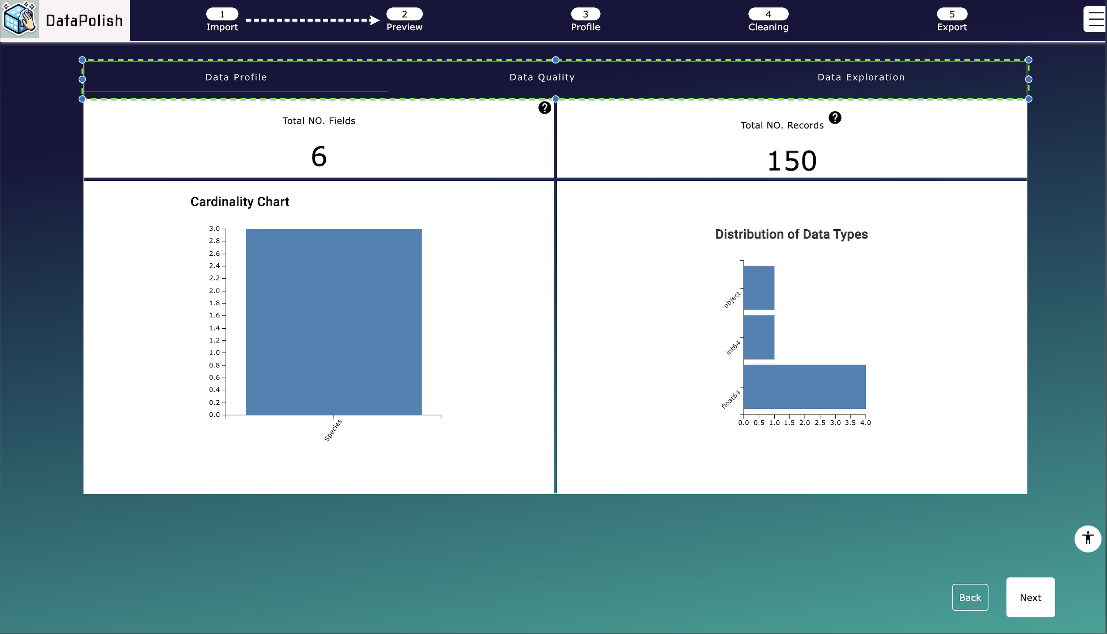

## Data Profile Tab

### Overview:

The Data Profile helps you understand the fundamental structure of your data. It's designed to provide an overview of your data.

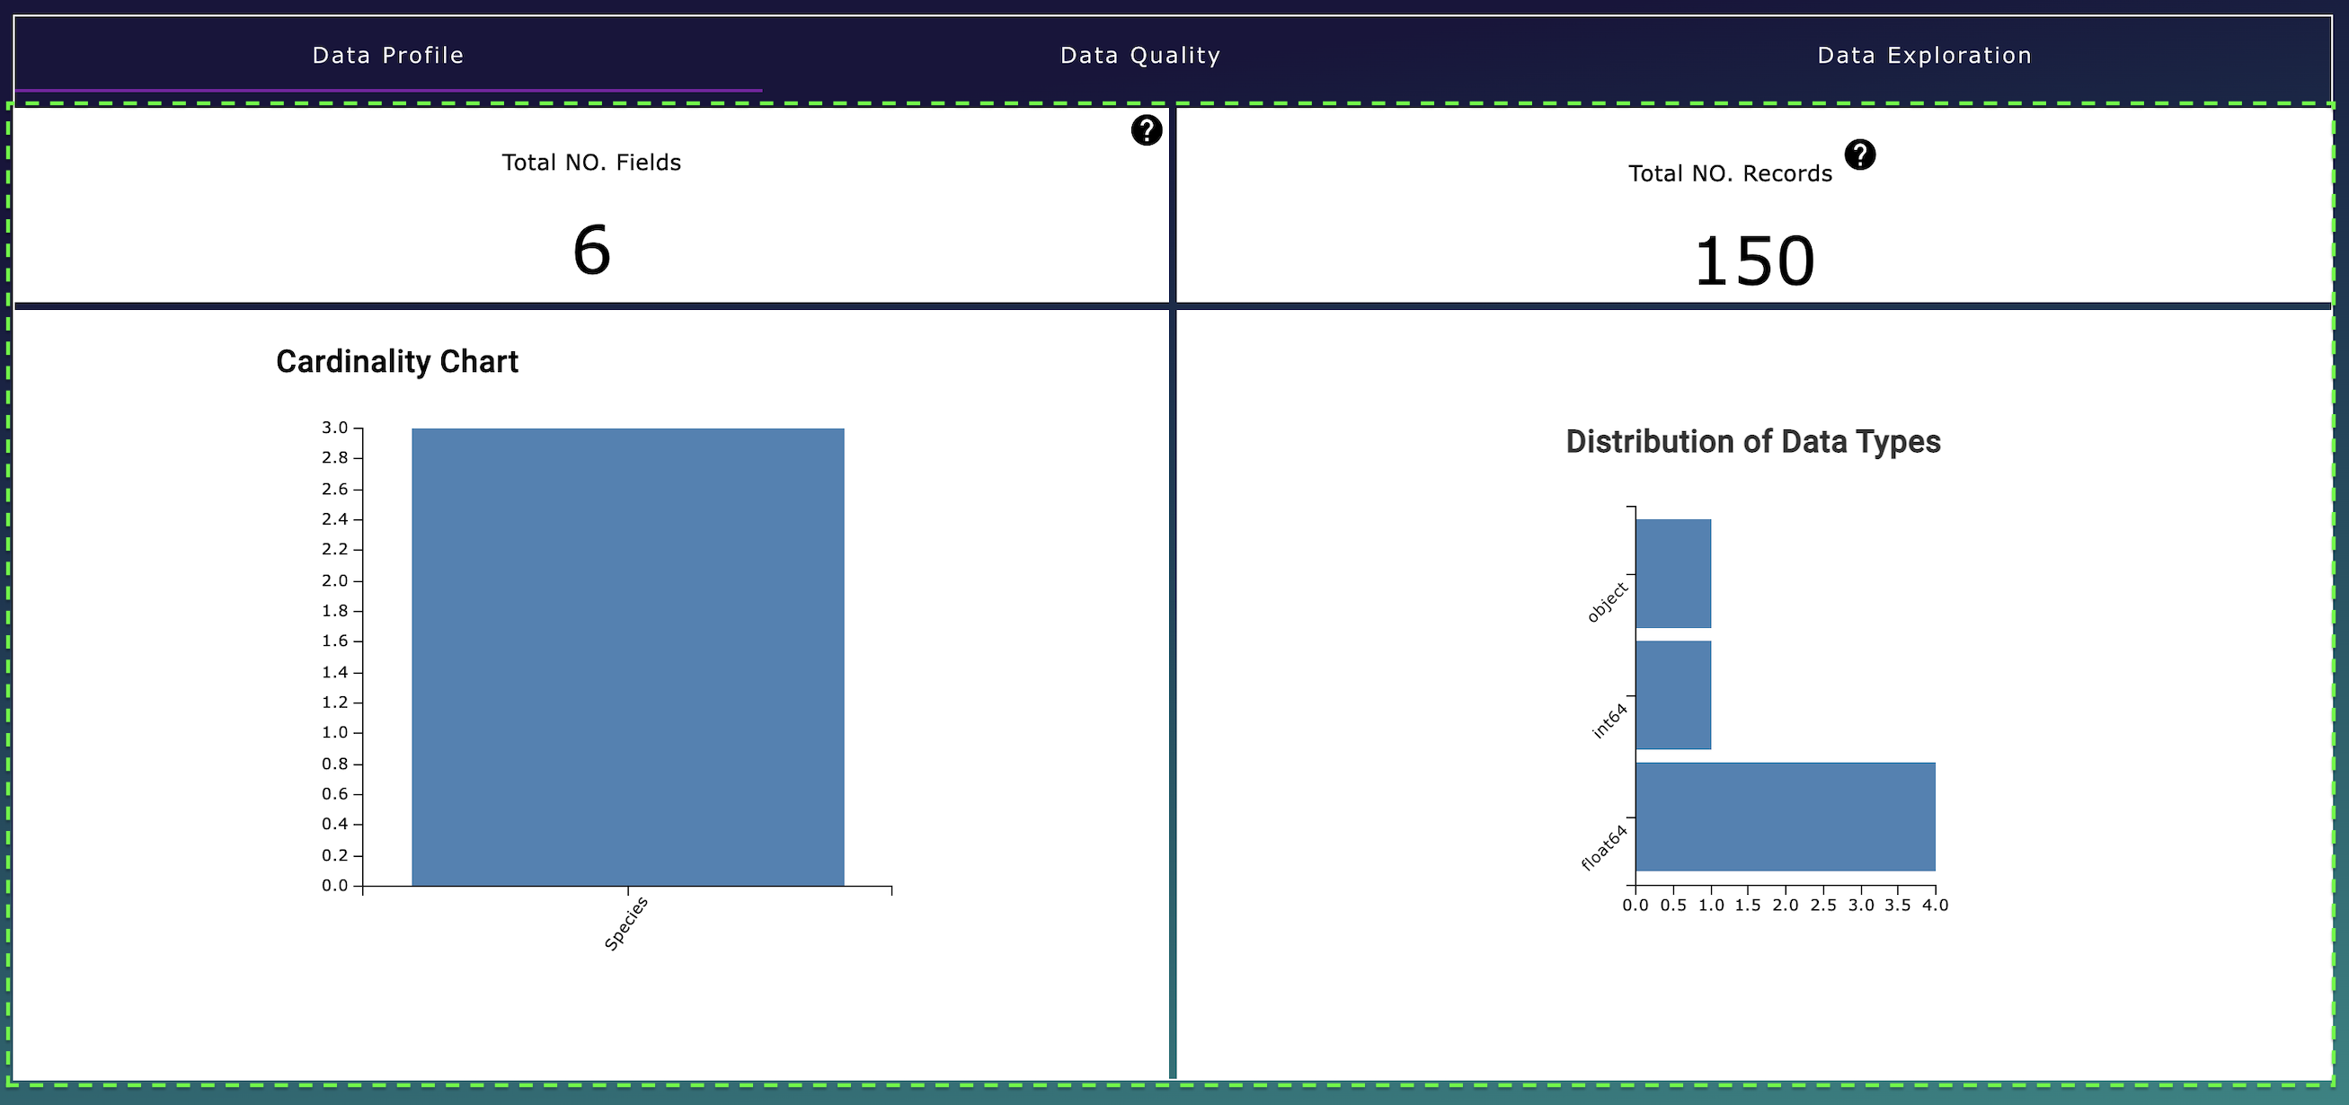

### Key Features:

**Record Count:** View the total number of records in your dataset.

**Field Count:** View the total number of fields, providing a glimpse into the dataset's complexity.

**Cardinality of Text Fields:** Understand the uniqueness of text data by exploring the cardinality, indicating the diversity in text fields.

**Data Type Distribution:** Examine the distribution of data types within your dataset. This feature helps in understanding the proportion of different data types like numeric, text, dates, etc.

### Visual Insights:

Below, you'll find a series of charts that visually represent these data attributes. These charts are designed to offer a clear and immediate understanding of your data's structure and composition.

Use the Data Profile tab to gain a deep and immediate understanding of the structure and nature of your data, setting the foundation for further data quality and exploration activities.

## Data Quality tab:

### Overview

The Data Quality tab is designed to provide you with an understanding of the quality of your data. This tab is a powerful tool for identifying and guiding you to clean your data.

### Key Features:

**Duplicate Record Identification:** Discover the number of duplicate records in your dataset.

**Data Quality Score:** Gives you a summarized view of your data's quality through a comprehensive score. This score is a quick indicator of the overall health of your data.

**Missing Values Chart:** Easily identify fields with missing values and quantify the extent of these gaps in your data.

### Data Quality Score Attributes:

The Data Quality Score is broken down into four key attributes, each representing an aspect of data quality:

**Completeness**: Assessing whether all necessary data fields are filled.

**Uniqueness**: Evaluating the exclusivity of data entries.

**Consistency**: Ensuring that data formats and values are uniform across the dataset.

**Readability**: Determining the ease with which data can be read and understood by users and processing systems:

View these attributes in detail using the radar chart, providing a visual representation of your data’s strengths and areas for improvement.

Alternatively, click 'Expand' under the Data Quality score metric for a more detailed breakdown, as illustrated below.

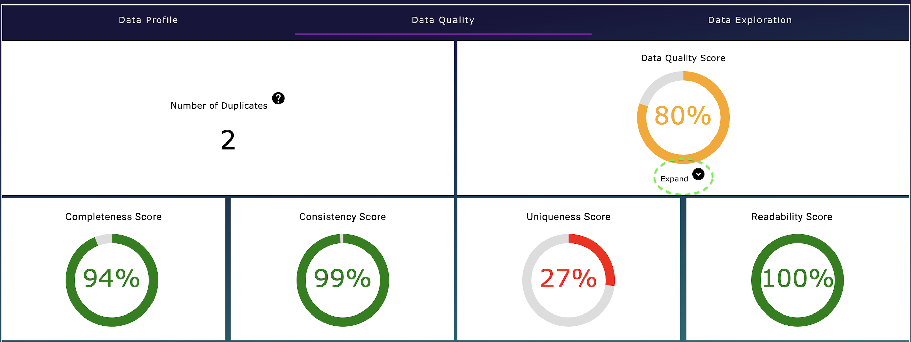

## Data Exploration tab

### Overview

The Data Exploration tab is an interactive and insightful component of your dashboard, designed to enable you to delve deep into your data and uncover insights. This tab is instrumental in visualizing and comprehending the complexities and relationships within your dataset.

### Key Features:

**Numerical Data Distribution:** Examine the spread and behavior of your numerical data. This feature helps you understand the range, median, and common patterns in your numerical data.

**Correlation Discovery**: Discover the relationships between various numerical variables. This is crucial for identifying trends and dependencies within your data.

**Outlier Scatter Plot Visualization**: Utilize scatter plots to visually identify and analyze outliers in your data. This tool is key in recognizing anomalies and unusual patterns.

**Bubble Chart for Categorical Data:** Dive deeper into your categorical data with the bubble chart. This interactive tool enables you to identify and understand the most prevalent values in a selected column, providing a clear view of categorical data distributions.

### Interactivity and Insight:

The Data Exploration tab is not just about viewing data; it’s about interacting with it. Each feature is designed to provide a hands-on experience, allowing you to engage with your data in a dynamic way.

Through these tools, you can effectively visualize complex data relationships, making it easier to extract meaningful insights and make informed decisions about your data cleaning.

## Quality of Life Features in the Dashboard

### Consistent Color Scheme:

**Color-Blind Safe Palette:** We have carefully selected colors that are accessible to individuals with color vision deficiencies. This ensures that all users can effectively interpret and enjoy our visualizations.

**Unified Color Consistency:** All visual elements adhere to a consistent color theme, resonating with the dashboard’s blue hue. This consistency not only enhances aesthetic appeal but also aids in intuitive navigation.

### Interactive Tooltips:

**Enhanced Information:** Non-metric visualizations are equipped with informative tooltips. These tooltips provide additional context and details, enriching your understanding of the data.

**Selection Highlighting**: Interactive elements respond to your cursor by highlighting selections. This feature allows for easy identification and navigation of choices within the dashboard.

### Helpful Text:

**Guidance and Context:** Each visualization comes with explanatory help text. This text addresses two key questions: What is the visualization showing, and why is it important? This feature aids in comprehending the relevance and application of the data presented.

### Smooth Transitions:

**Feedback Through Animation:** The dashboard includes subtle transitions, signaling that your data is being processed and analyzed. These animations provide a responsive and engaging user experience.

### Dynamic Titles:

**Contextual Awareness:** Certain visualizations feature dynamic titles that adapt based on the fields being analyzed. This helps you quickly grasp the focus and context of each visualization.

### Zoom Functionality in Bubble Chart:

**Enhanced Navigation:** The bubble chart is equipped with zoom in and zoom out capabilities. This functionality is especially useful when dealing with dense data, allowing you to adjust the view for a clearer understanding of all data points.

These quality-of-life features are designed to enhance your interaction with the dashboard, ensuring a user-friendly, accessible, and informative experience.

# Data Cleaning

## Overview

Welcome to the Data Cleaning Page, the fourth step in your data cleansing journey. This part of the manual provides a concise walkthrough of the page's features, from the top-left corner to the central cleaning functions.

As you navigate this page, you'll find the layout familiar, especially the bottom section, which mirrors the Preview Page from step two. This design consistency ensures ease of use, allowing you to seamlessly continue your data cleaning process with familiar tools and previews at your disposal.

In the following sections, we'll guide you through each feature and function, ensuring you have all the necessary tools for efficient data cleaning and optimization.

## Top section buttons:

The top section of the Data Cleaning Page features a series of buttons, each designed to streamline your data cleaning process.

Here's a brief guide, moving from left to right:

1. **Keep All:** This button selects all checkboxes in the 'Keep' column, indicating that you wish to retain all fields.
2. **Remove All:** Clicking this will deselect all columns in the data cleaning checkboxes, effectively removing them from the dataset.
3. **Reset Rules**: Use this to revert all the changes you've made on the page, resetting your data cleaning actions to their original state.
4. **Dataset Actions:** This opens a menu for dataset-wide cleaning actions like 'Remove Duplicates.' While currently limited to this action, future updates will expand these options. Your feedback is welcome to help us improve this feature.
5. **Save Rules:** It's essential to save the rules you create for data cleaning, ensuring the actions are correctly applied. This button does just that.
6. **Download Cleaning Rules:** This feature enables you to download your data cleaning configurations. It's useful for reviewing changes on one page or reapplying the same rules later, ensuring consistency in data cleaning.
7. **Import Cleaning Rules:** If you have previously configured rules, use this button to upload them. It saves time and maintains consistent data cleaning across sessions.

Each of these buttons is an integral part of the data cleaning toolkit, designed to make your experience as efficient and user-friendly as possible.

Column Cleaning

Column cleaning is in the middle section of the page and shows a table of each of the columns in your dataset, going vertically down that you may want to provide cleaning options to. Starting from left to right of the table

1. Field Name: The name of the field you want to clean in your dataset
2. Data type: The data type of the field, use this field to help you understand what cleaning options are available to that field.
3. Keep coloumn: